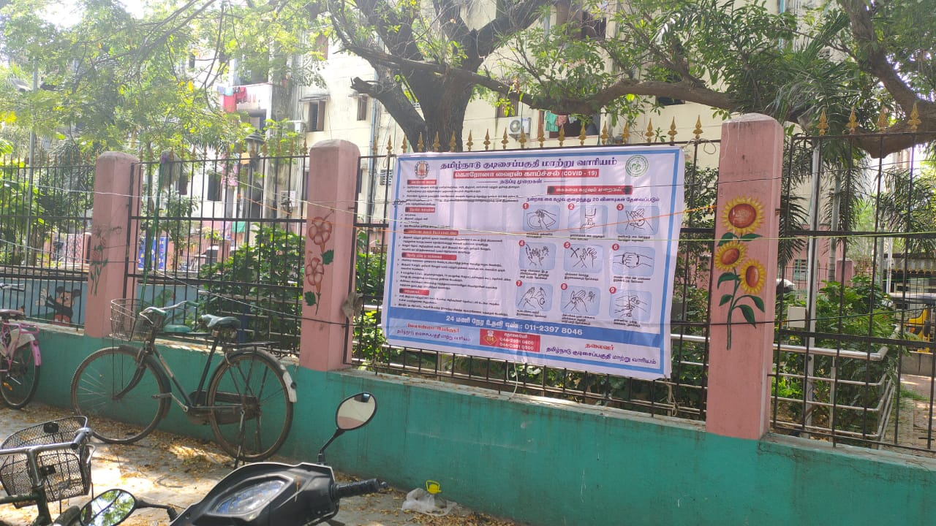

Fixing of CORONA Awareness Banner at
Rani Anna Nagar Slum Tenemental Scheme

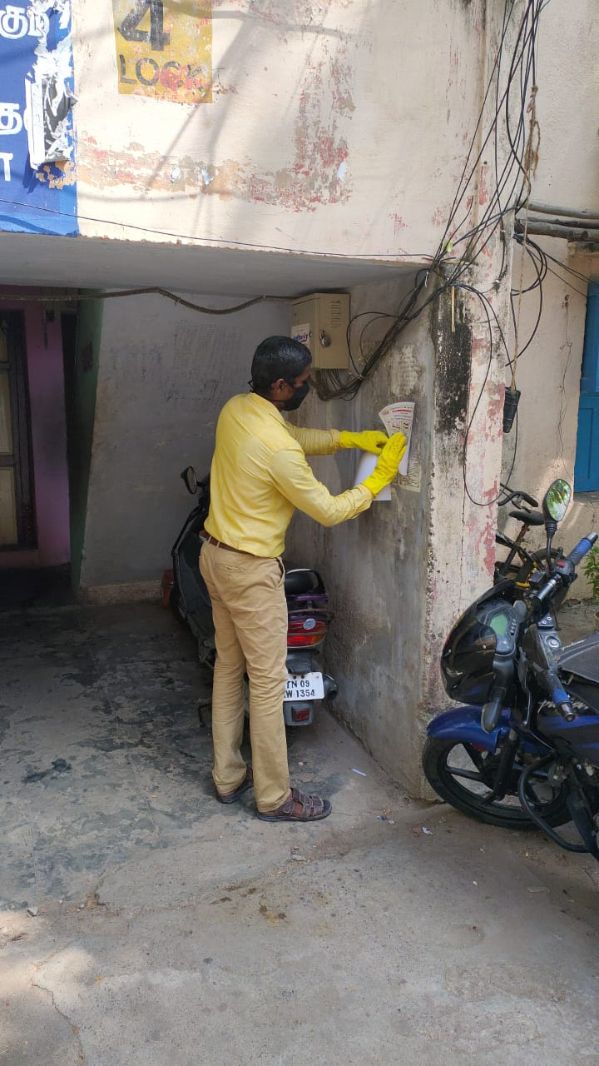
Awareness Stickers Fixing at Rani Anna Nagar Slum Tenemental Scheme

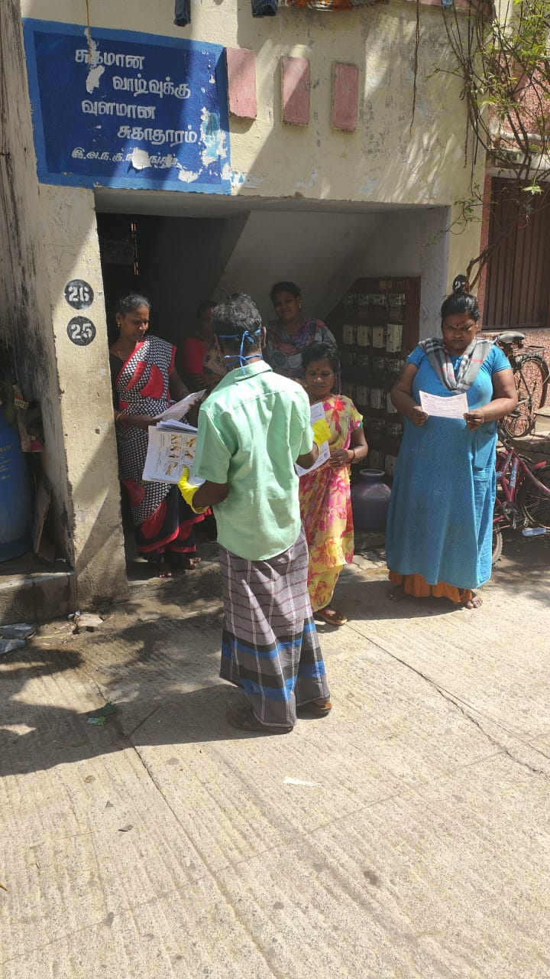
Pamphlets Issuing at Rani Anna Nagar Slum Tenemental Scheme

